Name:Hazem Hamdy Hanafy

Group:3

Sec:13

B.N:3

Topic: Artificial Intelligence

Application Brief: Today, the amount of data that is generated, by both humans and machines, far outpaces humans’ ability to absorb, interpret, and make complex decisions based on that data. Artificial intelligence forms the basis for all computer learning and is the future of all complex decision making. As an example, most humans can figure out how to not lose at tic-tac-toe (noughts and crosses), even though there are 255,168 unique moves, of which 46,080 end in a draw. Far fewer folks would be considered grand champions of checkers, with more than 500 x 1018, or 500 quintillion, different potential moves. Computers are extremely efficient at calculating these combinations and permutations to arrive at the best decision. AI (and its logical evolution of machine learning) and deep learning are the foundational future of business decision making

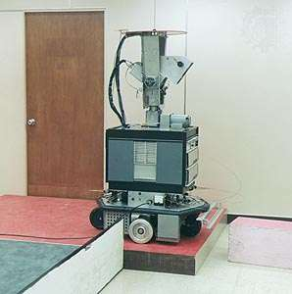

First robot John-McCarthy-father-

of-Artificial-Intelligence

Images from the project :-

